**Flight Delays and Cancellations**

**Created By\ Ahmed Darwish**

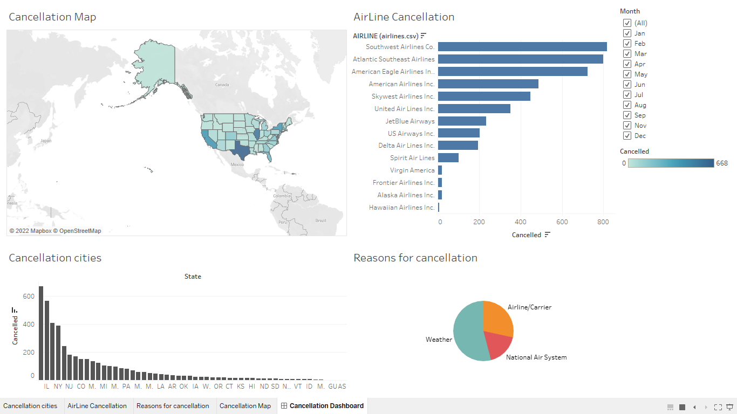

* **Link:** [Cancellation Dashboard](https://public.tableau.com/app/profile/adarwish98/viz/CancellationDashboard_16489983543320/CancellationDashboard)
* **Summary:** The dashboard contains a map of the cities, the most companies that cancel trips, the reasons for canceling trips, and the effect of the months of the year on all these results.
* **Design:** The graphic contains Airports delays, Causes delays, Airline Cancellation, Cancellation Map, and using months as a filter.
  + When all months are selected, Texas has the highest rate of cancellation for flights, Southwest Airlines Co. The owner of the highest cancellation rate for flights, the weather has the highest impact on flights.
* **Resources:** [Project Walkthrough](https://www.youtube.com/watch?v=9xqHA732LMA&feature=youtu.be)

**Q1\ Which airports have the worst delays?**

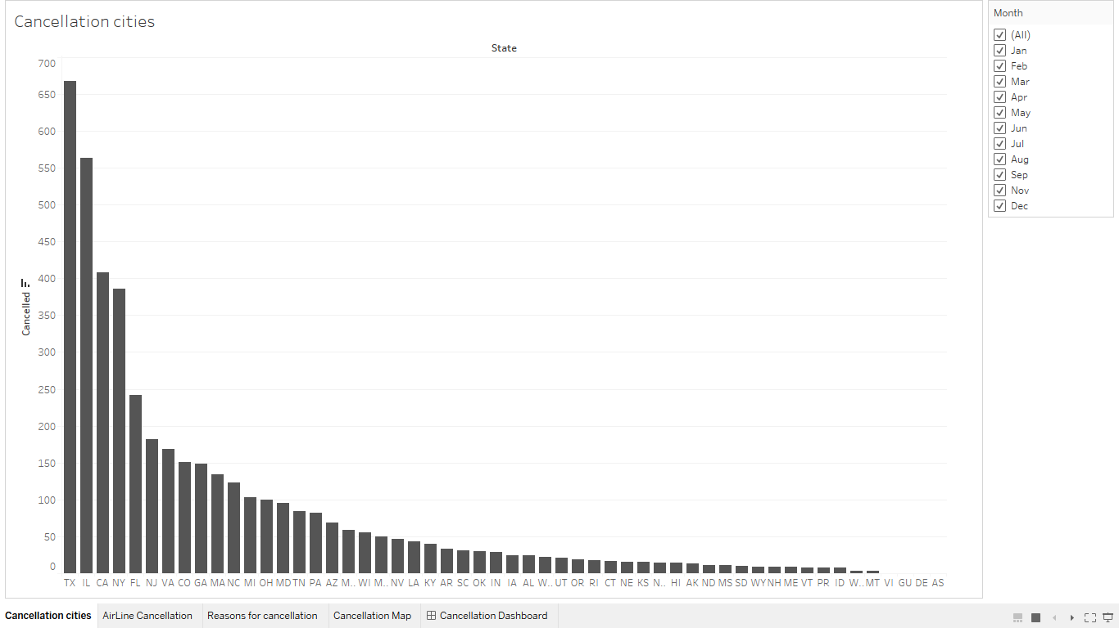

* **Link:** [Airports delays](https://public.tableau.com/app/profile/adarwish98/viz/Airportsdelays_16489988238780/Airportsdelays)
* **Summary:** A drawing showing the arrangement of the most airports that cancel flights, the effect of the months of the year on those airlines.
* **Design:** The graphic contains stats in columns, cancel sums in rows and months in the filter.
  + When all months are selected, Texas has the highest rate of cancellation for flights.
* **Resources:** [Project Walkthrough](https://www.youtube.com/watch?v=9xqHA732LMA&feature=youtu.be)

**Q2\ Which airlines have the worst delays?**

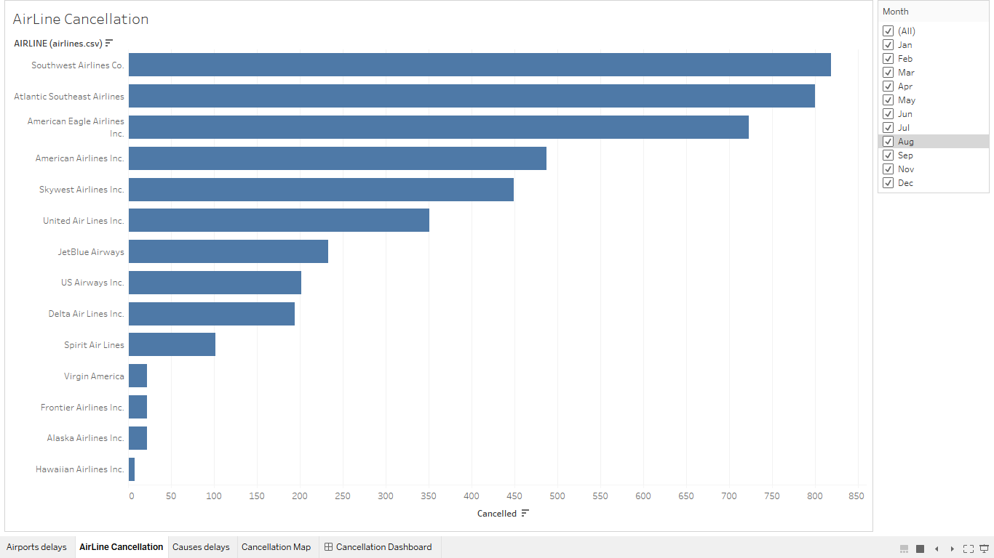

* **Link:** [Airline Cancellation](https://public.tableau.com/app/profile/adarwish98/viz/AirLineCancellation_16489991345100/AirLineCancellation?publish=yes)
* **Summary:** A drawing showing the arrangement of the most airlines that cancel flights and the effect of the months of the year on those airlines.
* **Design:** The graphic contains AirLines in columns, cancel sums in columns and months in the filter.
  + When all months are selected, Southwest Airlines Co. The owner of the highest cancellation rate for airmen.
* **Resources:** [Project Walkthrough](https://www.youtube.com/watch?v=9xqHA732LMA&feature=youtu.be)
* **Q3\ What causes delays?**

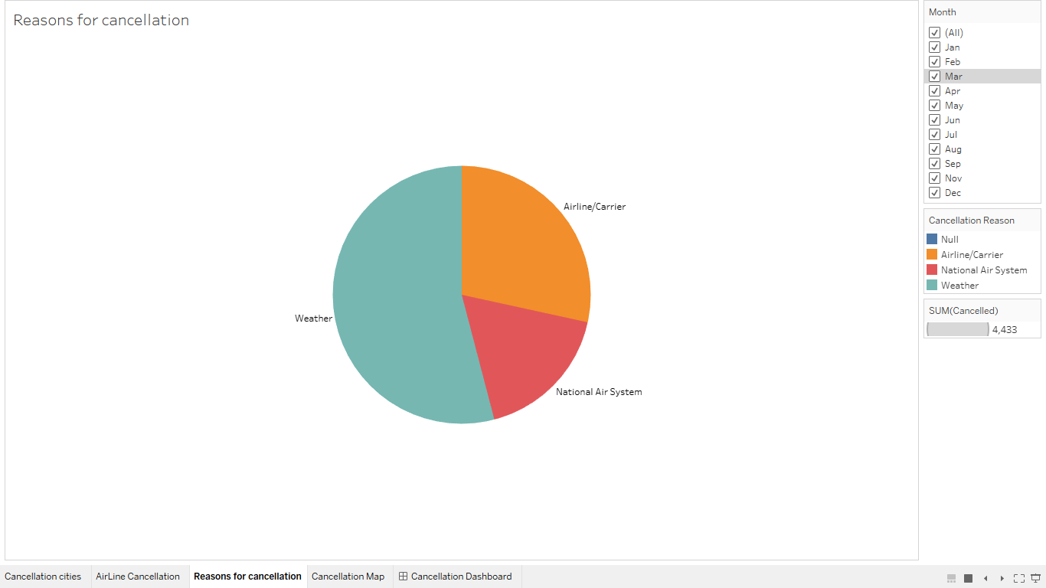

* **Link:** [Causes delays](https://public.tableau.com/app/profile/adarwish98/viz/Causesdelays_16489990098770/Causesdelays)
* **Summary:** The figure shows the reasons for canceling flights with factors such as

1. Airline/Carrier
2. Weather
3. National Air System

and the effect of months on these factors

* **Design:** The graphic contains Cancellation Reason in the colors and names filter and Cancelled in the Size filter and the effect of the months filter on them.
  + When specifying all months, the weather has the highest impact on flights.
* **Resources:** [Project Walkthrough](https://www.youtube.com/watch?v=9xqHA732LMA&feature=youtu.be)

**Q4\ What are the countries that cancel flights by months?**

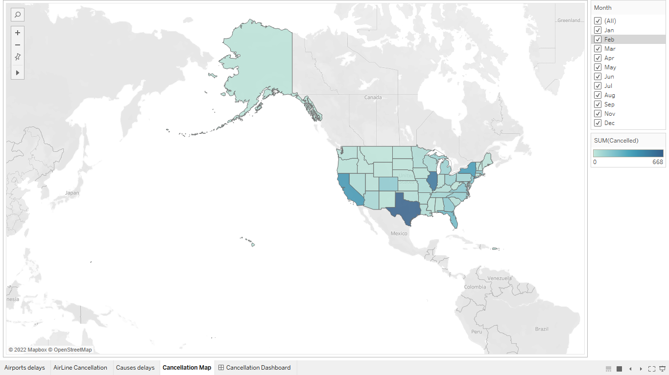

* **Link:** [Cancellation Map](https://public.tableau.com/app/profile/adarwish98/viz/CancellationMap_16490003304160/CancellationMap?publish=yes)
* **Summary:** The map shows the most canceled cities for trips and the effect of the months of the year on the percentage of travel.
* **Design:** he graphic contains Cancellation Sum in the colors and names filter and stats in the details filter and the effect of the months filter on them.
  + When all months are selected, Texas has the highest rate of cancellation for flights.
* **Resources:** [Project Walkthrough](https://www.youtube.com/watch?v=9xqHA732LMA&feature=youtu.be)